web_infrastructure_design

0-simple_web_stack
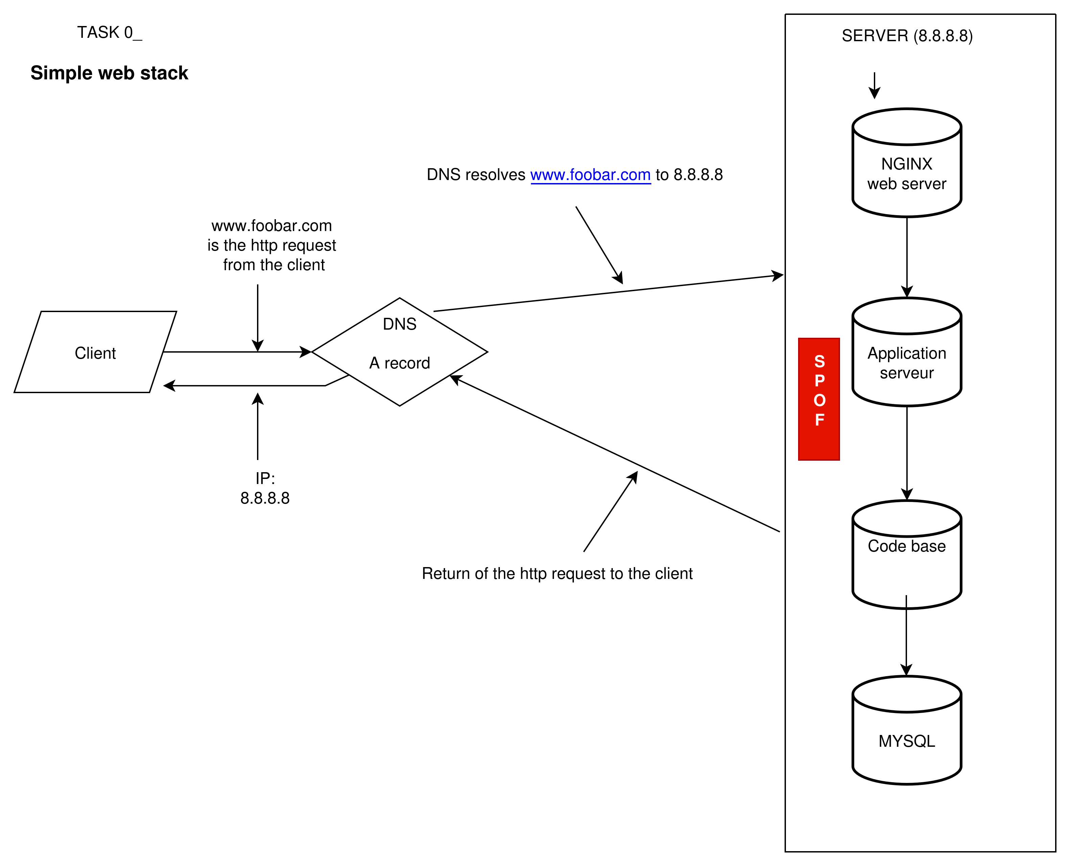

- What is a server
A server is a physical or virtual machines that provides computing ressources (CPU, RAM, Storage, network) to host services such as web servers, applications, and databases

- What is the role of the domain name
A domain name is a human-readable address that maps to an IP address, making it easier for users to access websites instead of remembering numbers.

- What type of DNS record www is in www.foobar.com
It is an A record (IPv4 address record) that points the domain name to the server’s public IP address (8.8.8.8).

- What is the role of the web server
The web server (Nginx) serves static content and forwards dynamic requests to the application server.

- What is the role of the application server
The application server executes the application code, processes business logic, and generates dynamic responses.

- What is the role of the database
The database (MySQL) stores persistent data, such as users, posts, or transactions, which can be queried and modified by the application.
- What is the server using to communicate with the computer of the user requesting the website
It uses the HTTP/HTTPS protocol over TCP/IP to send and receive requests and responses.

The problem with this type of infrastructure is that if the SPOF (Single Point of Failure) fails, the entire system will be out of service.
The same situation occurs if a maintenance operation is performed on the server: the whole infrastructure will remain unavailable for the duration of the maintenance.
In addition, this infrastructure is not designed to handle a large number of connections; even a simple DDoS attack could take down the server and make the entire website unavailable.

